

Abrasion Resistance Certification Report

이천시 대월면 대대리 576물류센터

검수의뢰자 : HEB

검수회사 :
ALLENFACE KOREA
서울시 강남구 봉은사로 326, 9층 985호(역삼동, 남전빌딩)

E-mail : allenface@naver.com
http://blog.naver.com/allenfacekorea
Abrasion Resistance
Survey Testing Report Index

- 검수 계약 사항 Information
- Abrasion Resistance 정의?
- Abrasion Resistance Specification
- Abrasion Certificate
- Summary of Survey Result
& Record Sheet & Photo

Information

이천 대대리 물류센터 의 Abrasion Resistance 검수에 대한 자세한 내용은 다음과 같습니다

Client : HEB
Construction Company : 보훈종합건설
Project : 이천 대대리 물류센터
Site : 경기도 이천시 대월면 대대리 576
Area : B2F ,1F ,3F ,4F 각 1 Point
Performance Class : “AR1” – BS 8204 – 2 : 2003 + A2 :2001
Survey Date : 2024.03.05

Test machine Spec :
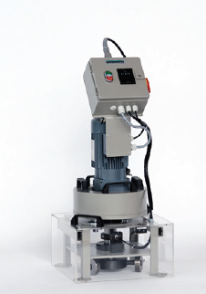
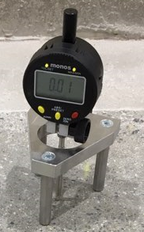
- Steel Wheels
- 최대직경 : 76mm
- 너 비 : 20mm
- 경 도 : 735HV
- 회 전 수 : 2,850±10
- 데스트시간 : 약15분
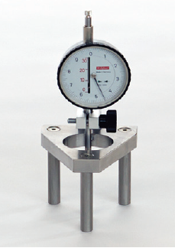
- 총 하 중 : 65±0.5kg
- 치 수 : 360 X 360 X 600mm
- 무 게 : 80kg
- 전 압 : 230V / 50HZ
Abrasion Tester Depth Gauge

Test measurement standard & method: BS EN 13892-4

What is Abrasion Resistance?

Abrasion resistance is the ability of a concrete surface to resist wear caused by rubbing, rolling, sliding, cutting and impact forces. Wear, which is the removal of surface material, is a process of displacement and detachment of particles or fragments from the surface. Abrasion mechanisms are complex and combinations of different actions can occur in many environments, for example, from truck tyres, foot traffic, scraping and impact. Excessive and early wear can becaused by the use of under-specified or under-strength concrete or water damage at the construction stage.
Tests are available to measure the abrasion resistance of concrete.

Guidance on performance classes, service conditions and typical applications, together with recommended abrasion resistance test limits, is given in Table 4 of BS 8204-2: 2002. Part of this Table is adapted and reproduced in Figure1.

The required abrasion resistance should be specified in relation to the service conditions. Differentiating between the service conditions described may be difficult. In practice, many floors will have a combination of uses, particularly when a variety of truck types operate on the floor. It is very common, for example, to find trucks with steel and plastic wheels operating together and also to find rubber-tyred counterbalance trucks operating in certain areas of a floor.

Inadequate abrasion resistance can be improved by in surface resin sealers. In more serious cases, mechanical removal of the surface, and the provision of a coating or screed, may be required.

Abrasion Resistance Specification

Performance classes for abrasion resistance, based on Table 4 of BS 8204-2 : 2003+A2:2011

Performance Class | Service  Conditions | Typical  Applications | BS8204 test  Limits (mm)
Special | Severe Abrasion or lmpact from Steel or hard nylon or neoprene wheeled traffic or scoring/scraping by dragging metal objects | Waste Transfer Stations, foundries, heavy engineering and other very aggressive environments | 0.05
AR1 | Very high Abrasion; steel or hard nylon or neoprene wheeled traffic and impact. Rubber-tyred traffic in areas subject to spillage of abrasive materials. | Production, warehousing and distribution | 0.10
AR2 | High abrasion; Hard nylon or neoprene wheeled traffic. | Production, warehousing and distribution | 0.20
AR4 | Moderate abrasion; rubber-tyred traffic | Light duty manufacturing, commercial, sporting and recreational uses | 0.40

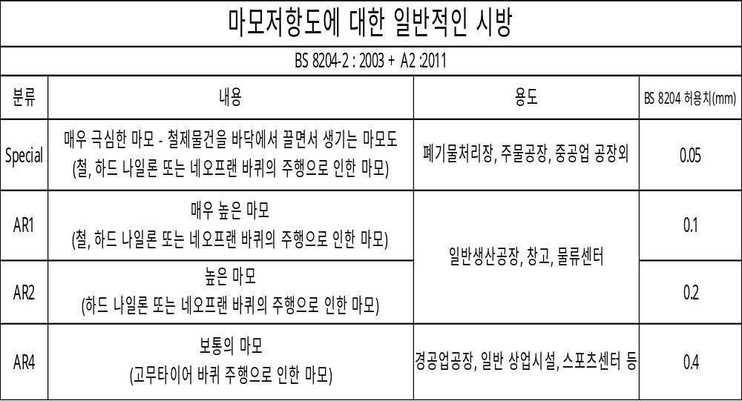
Abrasion Resistance Certificate

Client : HEB
Construction Company : 보훈종합건설
Project : 이천 대대리 물류센터
Site : 경기도 이천시 대월면 대대리 576
Area : B2F, 1F ,3F ,4F 각 1 Point
Performance Class : “AR1” – BS 8204 – 2 : 2003 + A2 :2001
Survey Date : 2024.03.05

Performance Class
"AR 1"

Certificate of EN 13892-4 & BS 8204-2 Compliance

ALLENFACE KOREA hereby certifies and pass that 100% conform
to the contract floor Abrasion Resistance specification.


